EXP 36: Write a Prolog Program to implement Best First Search algorithm.
AIM
To write and implement a Prolog program to perform Best First Search using heuristic values to find the path from the initial state to the goal state.
Program:
%%writefile bestfirst.pl

% Graph connections
edge(a, b).
edge(a, c).
edge(b, d).
edge(b, e).
edge(c, f).
edge(c, g).
edge(d, h).
edge(e, h).
edge(f, h).
edge(g, h).

% Heuristic values
heuristic(a, 7).
heuristic(b, 6).
heuristic(c, 4).
heuristic(d, 5).
heuristic(e, 3).
heuristic(f, 2).
heuristic(g, 3).
heuristic(h, 0).

% Best First Search
bestfirst(Start, Goal, Path) :-
search([[Start]], Goal, RevPath),
reverse(RevPath, Path).

search([[Goal|Rest]|_], Goal, [Goal|Rest]).

search([ [Node|Rest] | Others], Goal, Path) :-
findall([Next,Node|Rest],
(edge(Node, Next),
\+ member(Next, [Node|Rest])),
Children),
append(Others, Children, NewQueue),
sort_queue(NewQueue, SortedQueue),
search(SortedQueue, Goal, Path).

% Sort paths by heuristic value
sort_queue(Queue, Sorted) :-
predsort(compare_paths, Queue, Sorted).

compare_paths(Order, [A|_], [B|_]) :-
heuristic(A, HA),
heuristic(B, HB),
compare(Order, HA, HB).
!swipl -q -s bestfirst.pl -g "bestfirst(a, h, Path), write('Best First Search Path: '), writeln(Path), halt."
Out[put:
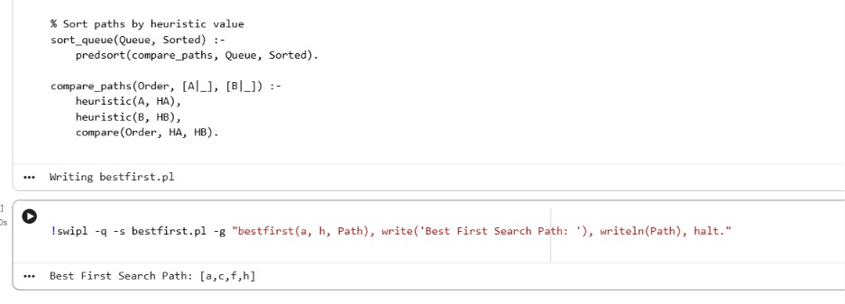

Exp 37: Write the prolog program for Medical Diagnosis.
AIM
To write and implement a Prolog program for Medical Diagnosis using symptoms and logical rules to identify possible diseases.
Program:
prolog_code = """
% Symptoms
symptom(fever).
symptom(cough).
symptom(headache).
symptom(sneezing).
symptom(body_pain).

% Medical diagnosis rules
disease(flu) :-
symptom(fever),
symptom(cough),
symptom(body_pain).

disease(common_cold) :-
symptom(sneezing),
symptom(cough).

disease(malaria) :-
symptom(fever),
symptom(headache),
symptom(body_pain).

% Display diagnosis
diagnosis :-
disease(Disease),
write('Possible Disease: '),
write(Disease), nl,
fail.

diagnosis.
"""

with open("medical.pl", "w") as f:
f.write(prolog_code)

!swipl -s medical.pl -g "diagnosis, halt."
Output:
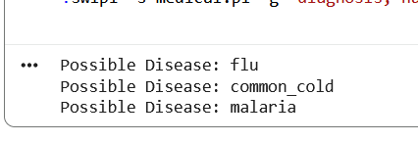
Exp 38 Write a Prolog Program for forward Chaining. Incorporate required queries.
AIM
To write and implement a Prolog program to demonstrate Forward Chaining using facts and rules to derive new conclusions from the available knowledge base by incorporating appropriate queries.
Program:
prolog_code = """
% Declare dynamic predicate
:- dynamic fact/1.

% Initial facts
fact(sunrise).
fact(morning).

% Rules
rule(day) :-
fact(sunrise),
fact(morning).

rule(bright) :-
fact(day).

rule(active) :-
fact(day),
fact(bright).

% Forward Chaining
forward :-
rule(X),
\\+ fact(X),
assertz(fact(X)),
write('New Fact: '), write(X), nl,
!,
forward.

forward :-
write('Forward Chaining Completed'), nl.

% Display all facts
show_facts :-
fact(X),
write(X), nl,
fail.

show_facts.
"""

with open("forward.pl", "w") as f:
f.write(prolog_code)

!swipl -s forward.pl -g "forward, write('Final Facts:'), nl, show_facts, halt."
Output:
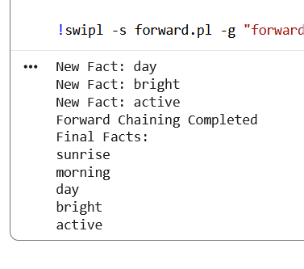
Exp 39 Write a Prolog Program for backward Chaining. Incorporate required queries.
AIM
To write and implement a Prolog program to demonstrate Backward Chaining using facts and rules to prove a given goal by working backward from the conclusion to the required conditions.
Program:
prolog_code = """
% Initial facts
fact(fever).
fact(cough).
fact(body_pain).

% Rules
disease(flu) :-
fact(fever),
fact(cough),
fact(body_pain).

disease(common_cold) :-
fact(cough),
fact(sneezing).

% Backward Chaining Query
diagnosis(Goal) :-
disease(Goal).

% Display diagnosis
check(Goal) :-
(diagnosis(Goal) ->
write(Goal), write(' is proved.'), nl
;
write(Goal), write(' cannot be proved.'), nl
).
"""

with open("backward.pl", "w") as f:
f.write(prolog_code)

!swipl -s backward.pl -g "check(flu), check(common_cold), halt."
Output:
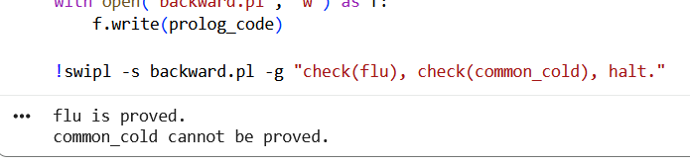

Exp 40 Create a Web Blog using Word press to demonstrate Anchor Tag, Title Tag, etc.
AIM
To create a web blog using WordPress and demonstrate basic HTML tags such as Anchor Tag, Title Tag, Heading Tag, Paragraph Tag and Image Tag.
Program:
from IPython.display import display, HTML

html_code = """
<!DOCTYPE html>
<html>
<head>
<title>My Technology Blog</title>
</head>
<body>

<h1>Welcome to My Technology Blog</h1>

<h2>Introduction</h2>

<p>Technology makes our life easier.
It helps us communicate and learn new things.</p>

<h2>Popular Technologies</h2>

<p>Artificial Intelligence</p>
<p>Machine Learning</p>
<p>Web Development</p>

<h2>Useful Website</h2>

<a href="https://www.google.com" target="_blank">
Visit Google
</a>

<br><br>

<img src="https://placehold.co/300x150"
alt="Technology Image">

</body>
</html>
"""

display(HTML(html_code))
Output:


